DnC & CnC Dashboard

DnC(Deliver and Carry) and CnC(Cash and Carry) are two different dashboard modules which share common js and css files. Most of the UI part for both the dashboards are same. Every dashboard tab has a different database procedure and they all are well connected to cache redis server. The below tabs load on the click-on-load basis.

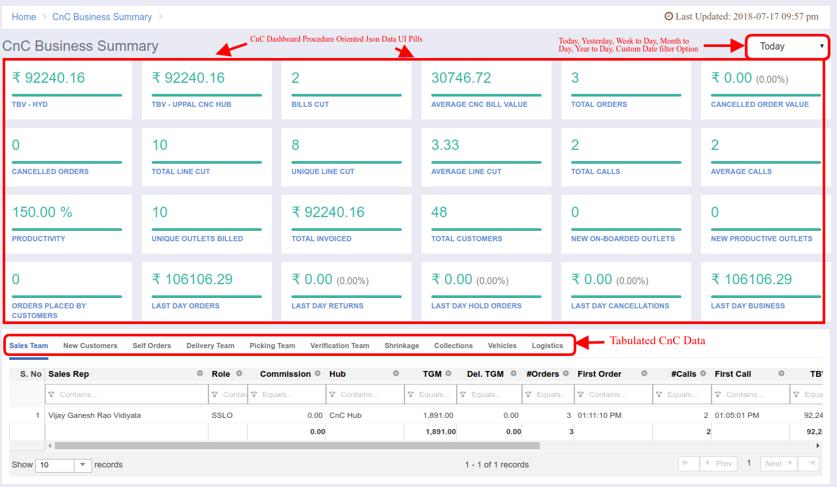

In the dashboard page, we have a date filter, which sends the respective dates to the procedures calls to fetch the results.  
  
Note: CNCDashboard tab does not have inventory tab.

Database:  
DnC Procedures List  
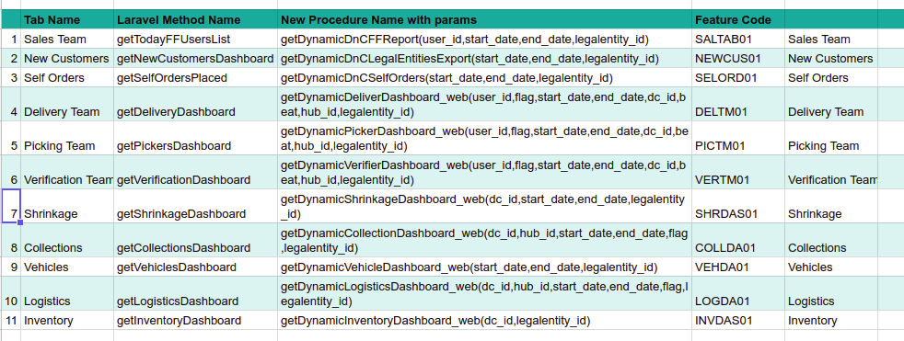

Cnc Procedures List

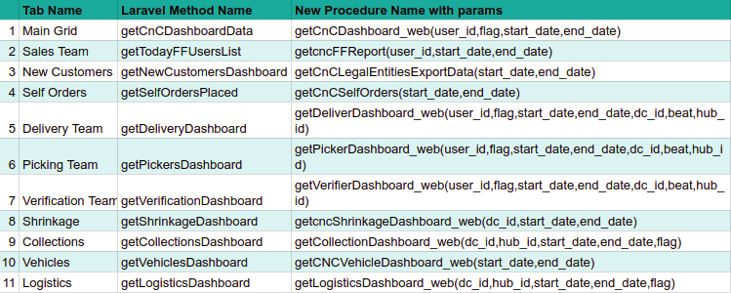

Whenever the user click the dashboard tab, then there is an ajax call associated to it and it hits that particular method and then, that laravel method controller calls the cache server and if the data found, then it would return same to the view, but if not, than it would call the procedure and also put`s the same in to cache server, later there is a common function which bifurcates the database procedure data from json to igGrid table view.

Code Details:

Module Name: **Dashboard & CNCDashboard**URL: <http://portal.ebutor.com/> and <http://portal.ebutor.com/cnc>  
Feature Codes: Written above  
Procedure Details: https://docs.google.com/spreadsheets/d/1DyuVw_vHsnSgsf4oKkW4pqfsiCQ27Po5Ixf5qbrVBTE/edit?usp=sharing